GippGipp 

**Reminders**

**Day 4:** **Home PTM**

**Day 14**: **Special Activity**

**Day 22 & 23:** **Unit Test-6**

**Star student of the month**

**K3- Sangamitra**

**Dates to remember**

**Day1**:- Colour of the month (Pink).

**Day3:-** **Outdoor Activity:-.**K3- Shadow Play,

K2- Out campus community helpers,

**Field Trip**: K2-Fire Station  
**Day4**:- Home PTM (Arni).

**Day 7:** **Talent Hunt Show**:- K1: Recitation/ K2: Go as you like, K3: Amazing Handicrafts

**Day8**:-**Indoor Activity**:- **K1:** Shadow Play

**Day 13- 17**:- “**Care for Animal” week**

**Day14:** **Special Activity- Valentine’s Day**

**Day22 & 23**:- Unit Test-6

**Day28:- Field Trip: K3-Museum**

***Vol-II; Issue-VII***

***January - 2017***

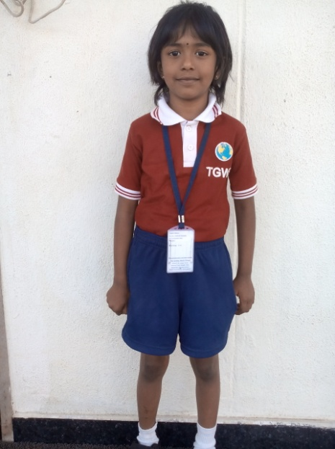

**GC3- Geekay’s Carnival-Cultural-Celebration becomes the Talk of the Town  
The Geekay World School’s Carnival-Cultural –Celebration equation –GC3 which is an Annual Showcase done on a novel theme captured the attention of the spectators with a fine blend of foodie shopping, cultural extravaganza and festivity celebration. The theme –Flavors of Films, being an evergreen topic, permeated to all the ages across, among the audience inviting enthusiasm and excitement from the viewers. Fantasy dances, science fiction themes, Biographical events and other flavors of films came live on stage on 11th and 12th of January, 2017.The programmes witnessed the grand finale of Pongal Celebration and dispersed on a positive note of New Year Greetings and Pongal Greetings to everyone.GC3 brought in lively memories for the everyone to cherish on both the days.**

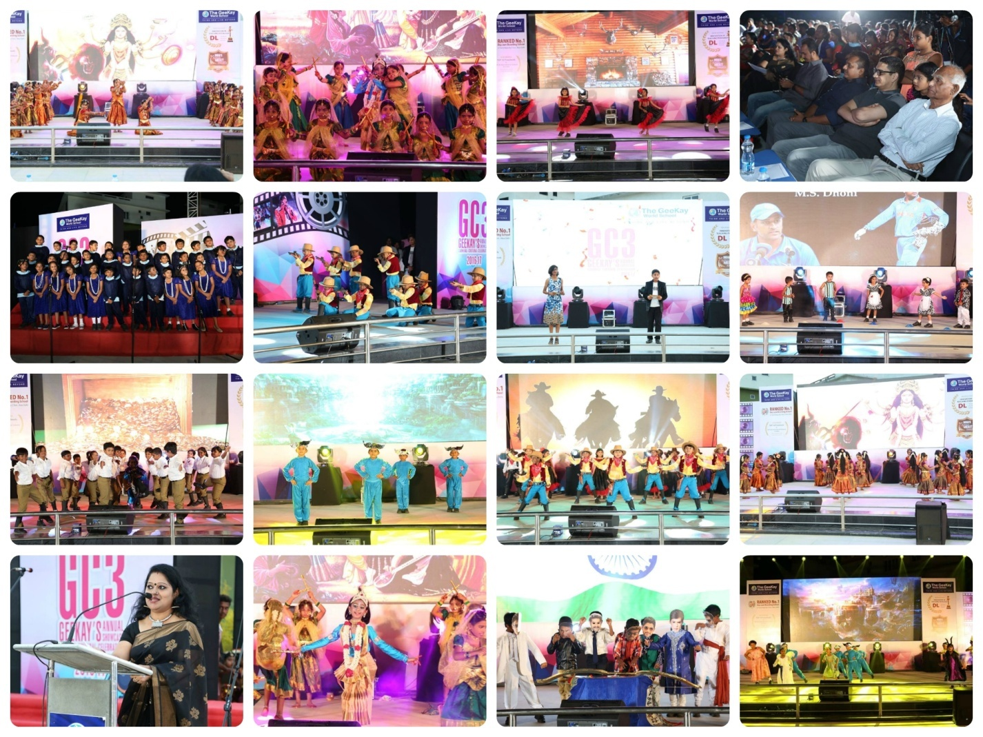

**The Theme -‘Bharath Humko Jaan Se Pyara Hai’ (I love my India more than my Life), brought the 68th Republic Day Celebration at TGWS on 26th January, 2017- more pride filled and encouraging. When the national flag rendered the symbolic sense of ‘Unity in Diversity’, every Geekain, took pleasure in commemorating the long tiring journey of India to emerge as an independent, republic and secular country. The National Flag was hoisted by the Directors Mr.Vinod Gandhi and Mr.Santhosh Gandhi, transferring the fervor of patriotism to the school community. We want our students to take pride in BEING INDIAN!**

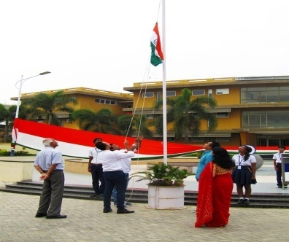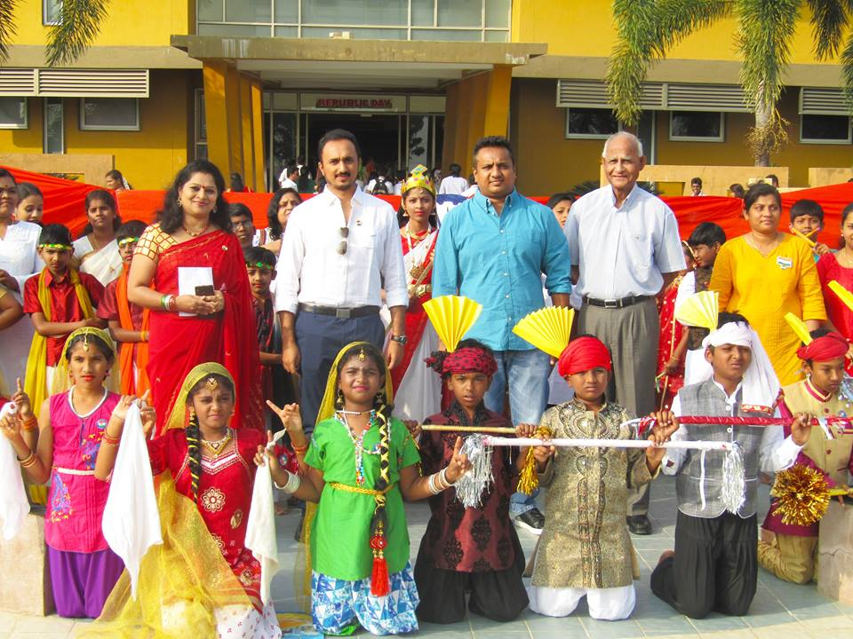

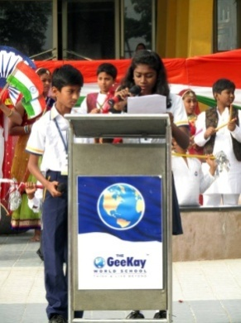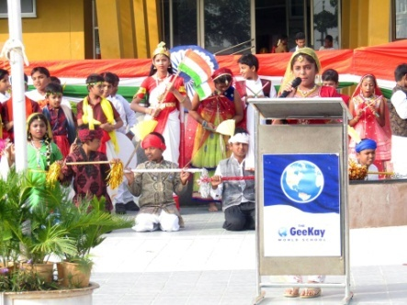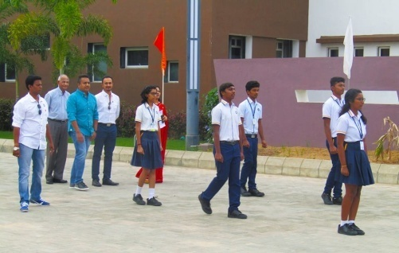

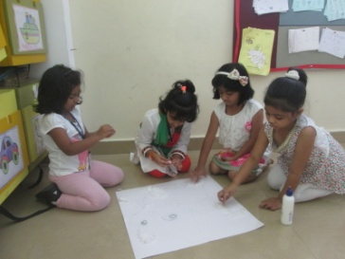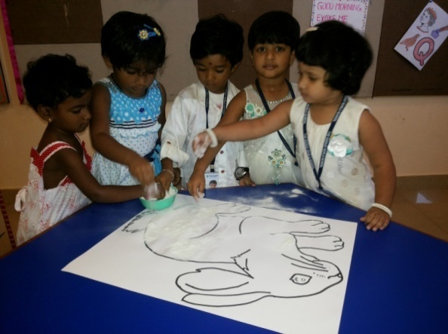**Color of the month activity was held on 3rd January. Children came to school in the shades of White. Children enjoyed doing art work like, Bunny, cat, fish, tiger, snowflakes….. etc.**

**We are making white cat**

**Adding beauty to our Bunny**

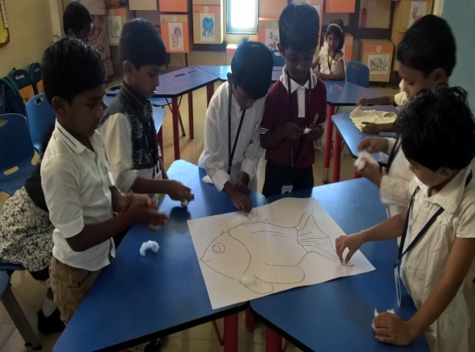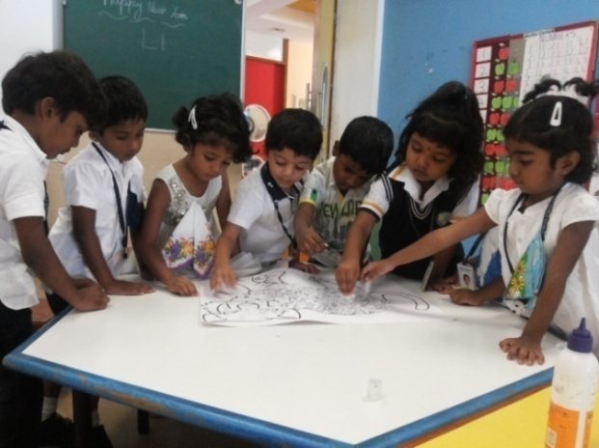

**Have u seen white fish???**

**See my brave white tiger …**

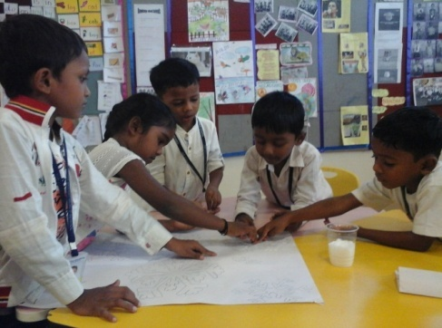

**One little snowflakes out of SAND..**

**Two little Snowflakes out of GLUE..**

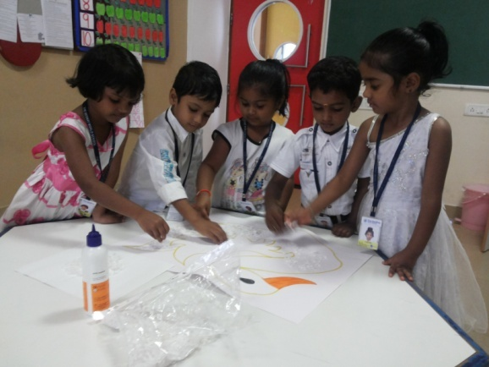

**Decorating our white swan**

**Indoor activities are played in social or family situations, or when darkness or bad weather prevent people from moving outside. Children of K3 made a Farm Corner integrated with concept “Animals” and K1 students decorated their Christmas tree.**

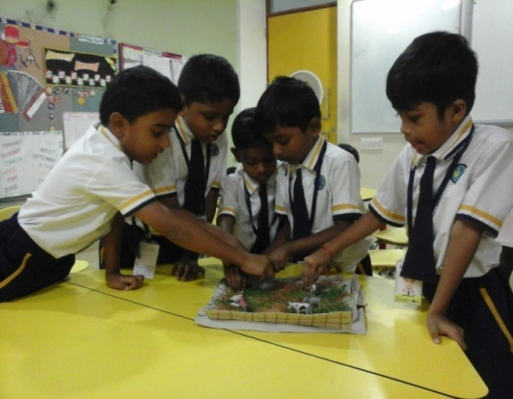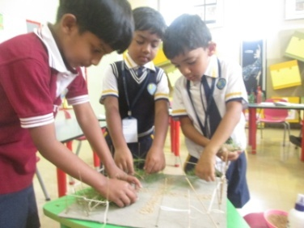

**We are happy to make a little farm**

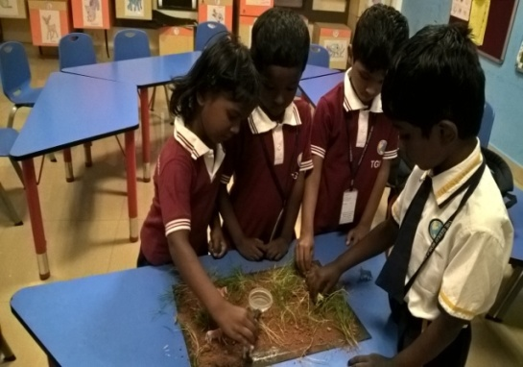

**We are farmers today and we just love doing that..**

**We love farming…**

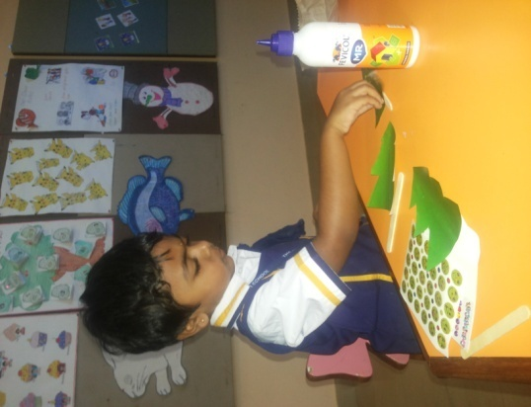

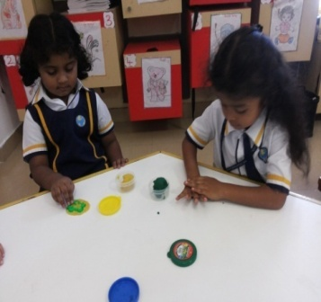

**Busy in decorating my Christmas tree**

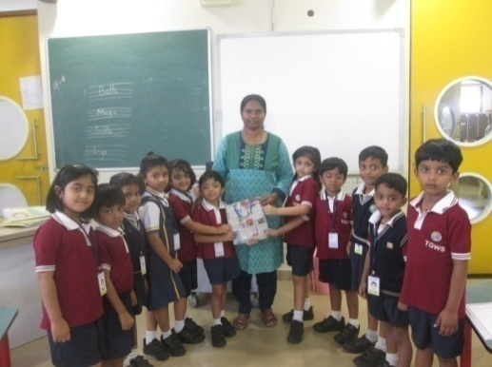**“ Say No To Plastic”, was an interesting activity. We observed this as a special week activity. Students made paper bags and gifted to others. This was to bring awareness amongst students towards the ill effects of plastic bag in daily life.**

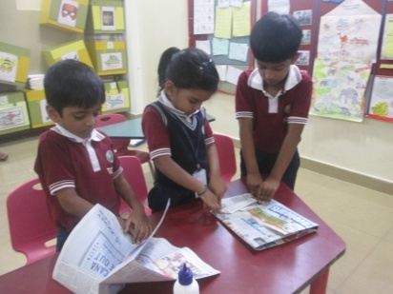

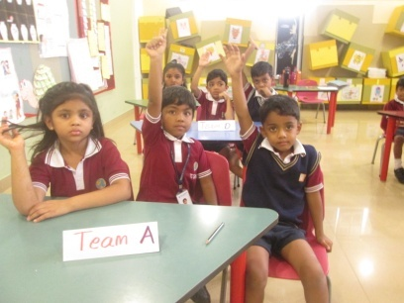

**Dear Ma’ am,**

**Please say no to plastic and use paper bags**

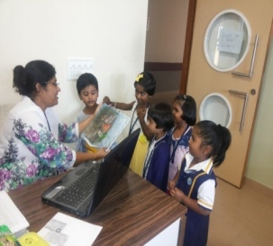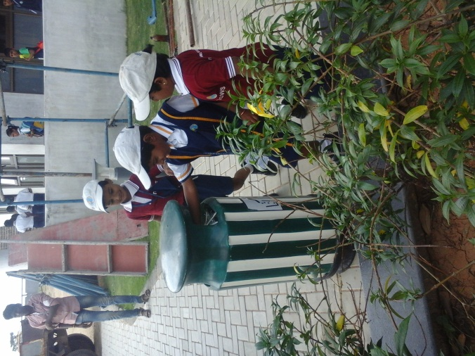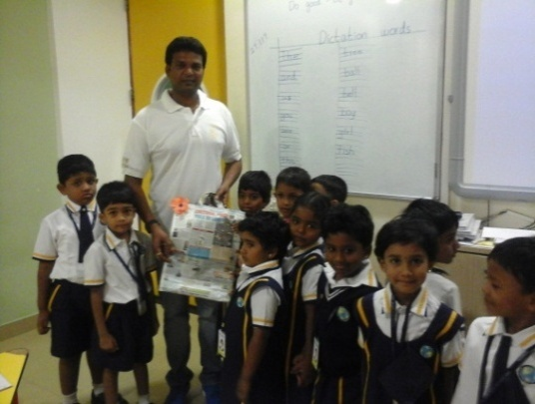

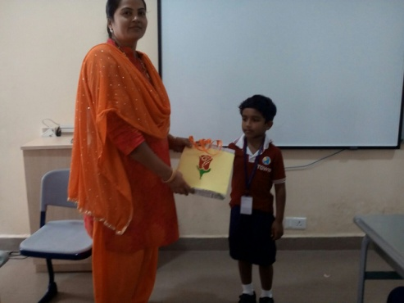

**Plastic bag replaced by our paper bag..**

**We throw away all the plastics found..**

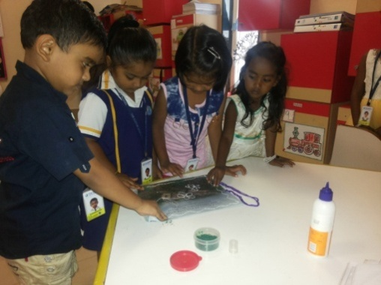

**Making paper bag**

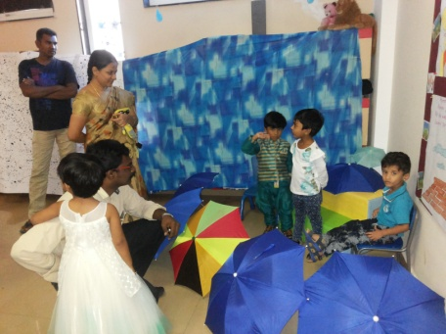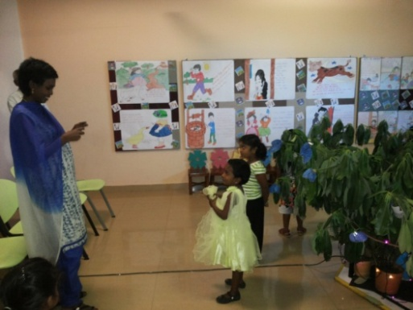**To prepare our students for the challenges of 21st century a skill oriented teaching-learning process is essential. Here the student should be at the centre of the learning. With this learning style, students become Managers of their learning process, guided and mentored by our skilled teachers. Keeping this in mind, to boost the innovative teaching and learning styles, Pre-Primary project Day was organized on 21st January’2017.The classrooms were live with Rhythmic land, Juicy Fruits, Famous Figures, Our own Interstellar, Find your own Shelter and Time travel to all seasons.**

**Lets water the trees and plants daily in the morning**

**Rain Rain go away..**

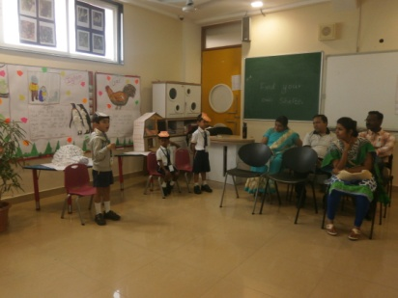

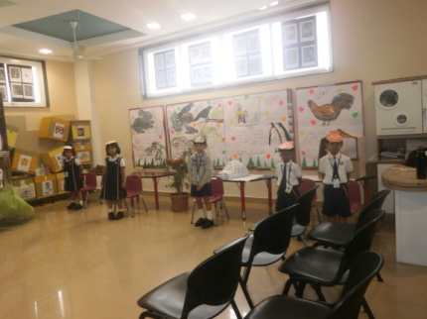

**Eskimos live in igloo**

**Find your own shelter**

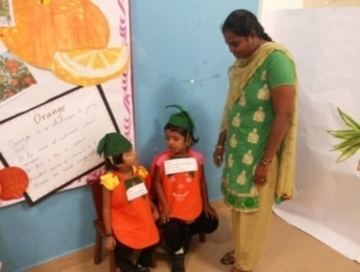

**Juicy fruits ….good for health**

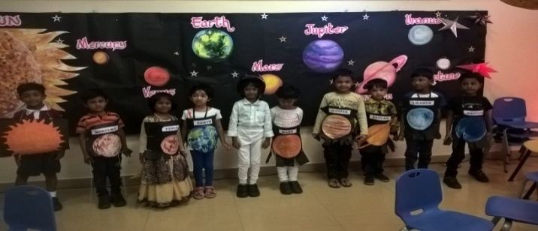

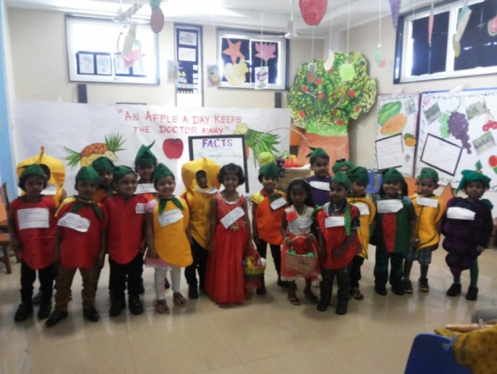

**We are the Sun family.**

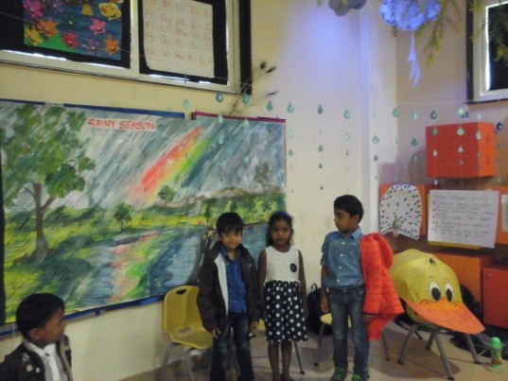

**Colorful fruits in our juicy land**

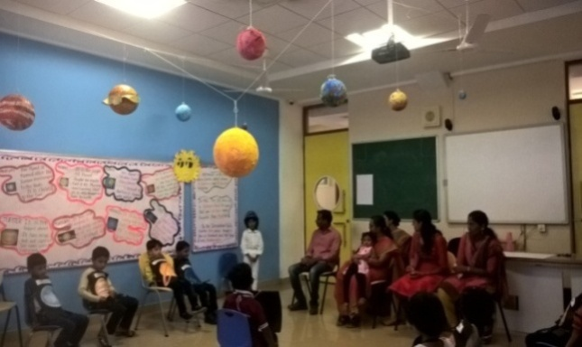

**Raindrops and thunder filled our rainy season..**

**Hey.. I am Kalpana Chawla.**

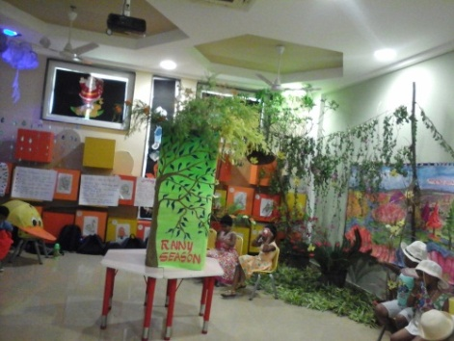

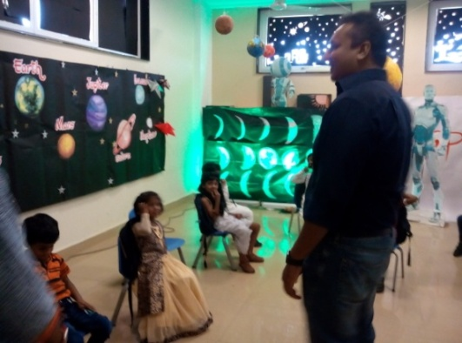

**Time travel to all seasons..**

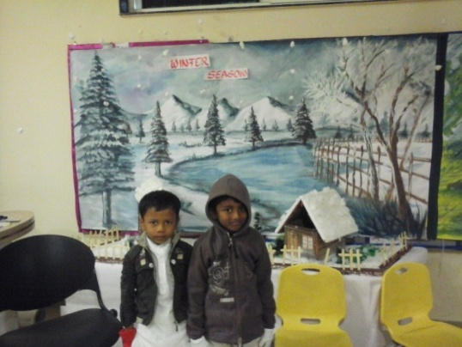

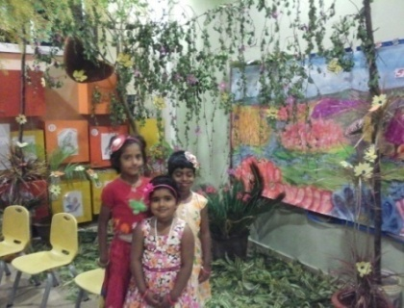

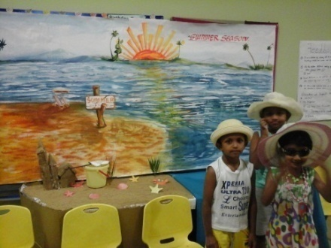

**Snowflakes and Santa made the Winter white..**

**Flowers in Spring..**

**Beach in summer..**

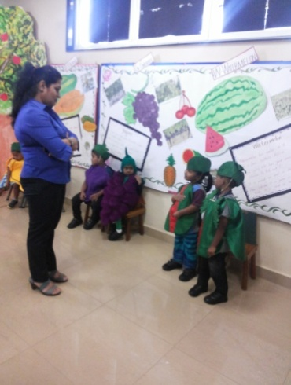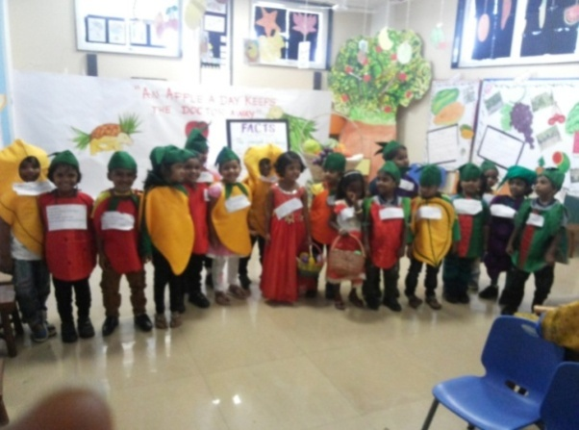

**Watermelon is oval or round in shape**

**Welcome to juicy land….**

**K1 students enjoyed playing colourful Balloons and students of K2 enjoyed visit to the Railway Station. They explored many different kinds of things, like railway tracks, rules and regulations which need to be followed while walking on to the platform.**

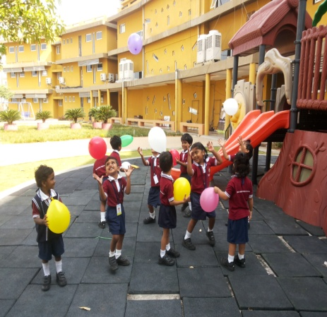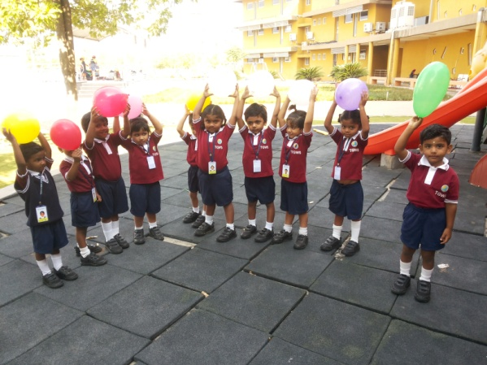

**It’s nice to hold the balloons.**

**Colourful balloons**

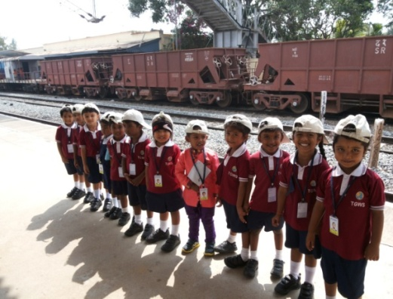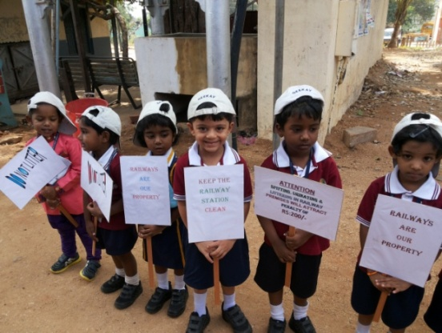

**Can you find a good train in the Picture**

**Don’t litter the station..**

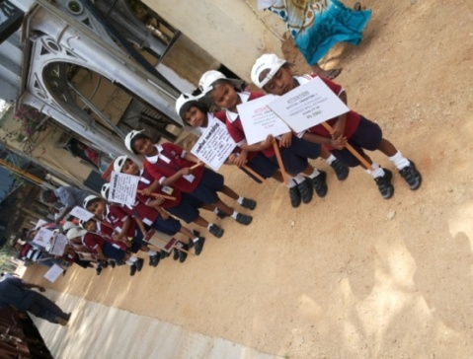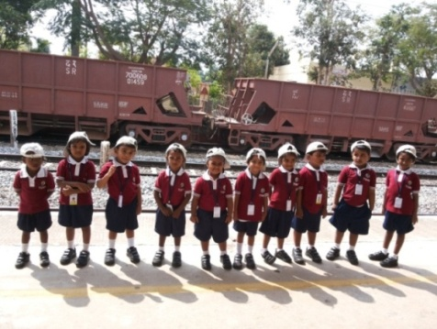

**A rally for awareness of passengers**

**Train is too long….**

**We had conducted an activity to showcase the singing abilities of our students. Students really enjoyed singing songs in their compatible languages.**

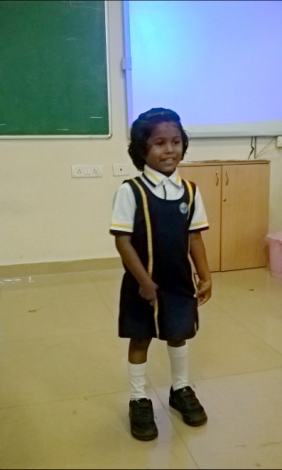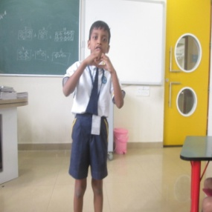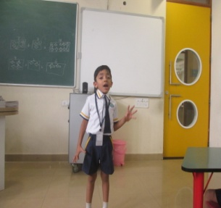

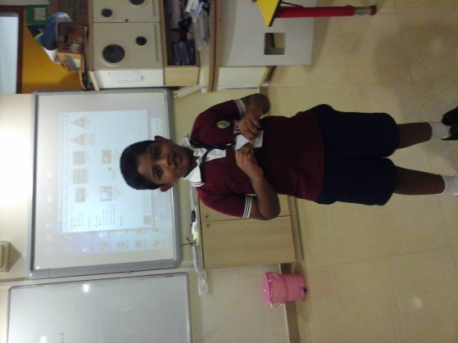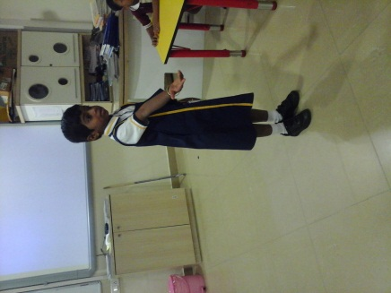

**Thirukural more cute in kinder words was just awesome to hear**

**Kaivisamma rhyme with action..**

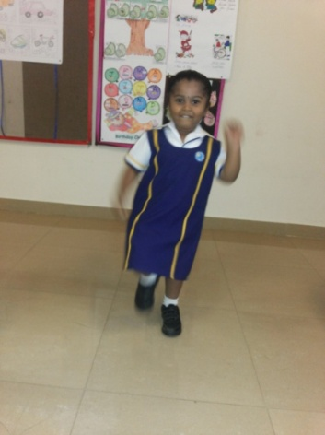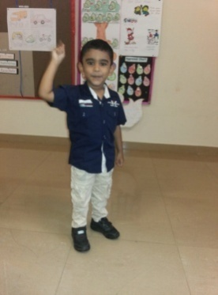

**Follow the beats**

**Tap your feet…**